Ideation Phase: Problem Statement Definition
An employee requests installation of licensed software through the Service Catalog
Date | 31 January 2025
Team ID | SWUID2026190351
Project Name | An employee requests installation of licensed software through the Service Catalog
Maximum Marks | 2 Marks

Customer Problem Statement Template
A well-articulated customer problem statement allows the team to understand user needs deeply and design an optimal solution. For our ServiceNow project, we analyze problem statements from both the End-User (Employee) and Administrative (IT Asset Manager) perspectives.

Detailed Problem Statements
Problem Statement | I am (Customer) | I'm trying to | But | Because | Which makes me feel
PS-1 (Employee) | An Enterprise Employee needing development & analytics tools (Docker, VS Code, MATLAB) | Request and install required software quickly to stay productive and deliver projects on schedule | The traditional request process takes days due to manual tickets and slow email approval chains | Provisioning relies on manual IT ticket processing and disconnected license management systems | Frustrated, unproductive, and blocked from fulfilling project deadlines
PS-2 (IT Admin) | An IT Software Asset Manager & Service Desk Administrator | Manage software requests efficiently, enforce compliance, and automate software deployment | The team is overloaded with manual installation tickets, untracked license counts, and audit risks | Lack of automated integration between ServiceNow catalog requests and endpoint tools (Intune/SCCM) | Overwhelmed, stressed regarding compliance audits, and burdened by low-value manual tasks

Visual Problem Statement Workflows
Figure 1: PS-1 End-User (Employee) Problem Journey
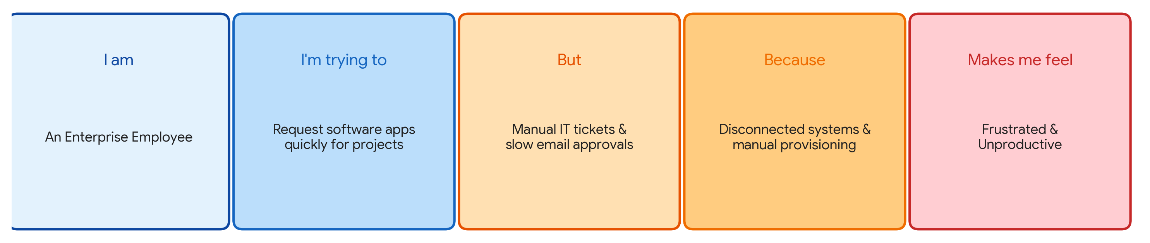

Figure 2: PS-2 IT Asset Manager & Admin Problem Journey
